Assignment-Chapter 3&4 (100 points)

Student Name: Jayadeep Reddy Karri ID: 664646469

1. Create a data frame with two column as:

time total_bill

Lunch 14.89

Dinner 17.23

Then use and write functions to draw four graphs, respectively. (30 points)

x <- data.frame( time = factor(c("Lunch","Dinner"), levels=c("Lunch", "Dinner")),total_bill = c(14.89, 17.23))

(a)

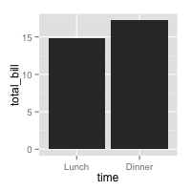

> ggplot(data=x, aes(x=time, y=total_bill)) + geom_bar(stat="identity")

(b)

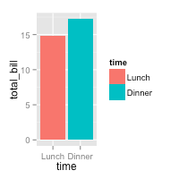

> ggplot(data=x, aes(x=time, y=total_bill, fill=time)) + geom_bar(stat="identity")

(c)

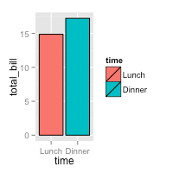

> ggplot(data=x, aes(x=time, y=total_bill, fill=time)) + geom_bar(colour="black",stat="identity")

(d)

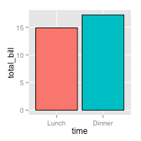

> ggplot(data=x, aes(x=time, y=total_bill, fill=time)) + geom_bar(colour="black",stat="identity") + guides(fill=FALSE)

1. Create a data frame with three column as:

sex time total_bill

Female Lunch 13.53

Female Dinner 16.81

Male Lunch 16.24

Male Dinner 17.42

Then use and write functions to draw four graphs, respectively. (30 points)

x1 <- data.frame( sex = factor(c("Female","Female","Male","Male")), time = factor(c("Lunch","Dinner","Lunch","Dinner"), levels=c("Lunch","Dinner")), total_bill = c(13.53, 16.81, 16.24, 17.42) )

(a)

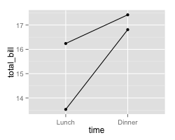

> ggplot(data=x1, aes(x=time, y=total_bill, group=sex)) +

+ geom_line() +

+ geom_point()

(b)

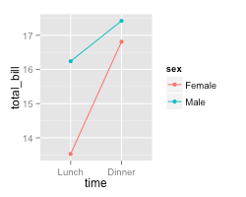

> ggplot(data=x1, aes(x=time, y=total_bill, group=sex, colour=sex)) +

+ geom_line() +

+

+ geom_point()

(c)

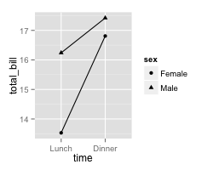

> ggplot(data=x1, aes(x=time, y=total_bill, group=sex, shape=sex)) + geom_line() + geom_point()

1. Use the data frame ToothGrowth to draw three graphs, respectively. (40 points)

> library(plyr)

> x3 <-ddply(ToothGrowth,c("supp", "dose"),summarise,length=mean(len))

(a)

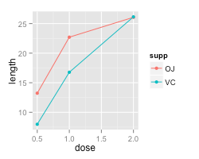

> ggplot(data=x3, aes(x=dose, y=length, group=supp, colour=supp)) + geom_line() + geom_point()

(b)

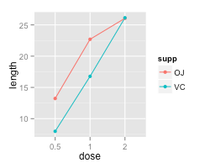

> x4 <- x3

> x4$dose <- factor(x4$dose)

> ggplot(data=x4, aes(x=dose, y=length, group=supp, colour=supp)) + geom_line() + geom_point()

(c)

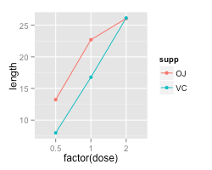

> ggplot(data=x4, aes(x=factor(dose), y=length, group=supp, colour=supp)) + geom_line() + geom_point()